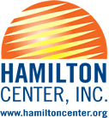
New Citizen Program Reality After Release

Data shows persons coming out of incarceration have the cards stacked against them.

- 67% recidivism rate
    - Lack of education pre and post release
        - Minimal job opportunities
            - Lack of structure and discipline
                - Desensitized to negative behaviors
                - Lack of permanent housing
                - Transportation issues
              - Lack of family support
            - Over confident or lack of confidence
            - Feelings of self-entitlement
      - Discouraged mindset towards reentry
      - Afraid of living an honest life
A Second Chance
Through the New Citizen program, Hamilton Center provides the opportunity for individuals who have been incarcerated and/or convicted of a felony, a second chance. In cooperation with the Department of Corrections, Community Corrections, County Jails, the Federal Bureau of Prisons and halfway houses, this program offers the opportunity for a new way of life.

“New Citizens” complete a one-year probationary period during which they train in four different areas of Hamilton Center to gain skills and experience. Throughout the program the “New Citizen” meets with a team of mentors led by the CEO and participates in a weekly meeting made up of program graduates, the CEO and others who have a role in the project during which time they report on their activities, concerns, etc. and receive feedback from the committee. Core Elements of the program include:

- Improve job skills and explore opportunities for job placement
  - Develop a career not just a job
    - Establish positive referrals/character references
      - Improve community perception
        - Develop positive relationships with community leaders
The opportunity is life changing for someone who has been involved in the criminal justice system and is willing to turn their life around. The program offers support from Hamilton Center staff and community leaders to bring confidence and motivation to someone who is willing to become a new citizen.

MENTORS ARE KEY
The New Citizen Committee is made up of mentors who meet with participants weekly during which time their performance at their current worksite is discussed along with how life is going as they are transitioning from incarceration. CEO, Melvin Burks, leads the team and is very involved in addressing issues, providing direction and encouragement.
How it Works

One male and one female are chosen each year after a series of interviews conducted by the CEO and the New Citizen Committee. If selected for participation, New Citizens have:

Participation in events and fundraisers in the community
Weekly meetings covering current position, family, and transition from incarceration
One year
probationary period working in 4 different departments for 3 months each

Daily interactions with mentors and other positive role models
The New Citizen Program is about supporting those who have made decisions that could negatively affect the rest of their lives. Hamilton Center has made it possible for these individuals to have a second chance. It is an extraordinary opportunity to start a new life, and travel down a supported path to success.
SUCCESS STORIES

TATU BROWN was a star high school athlete. He finished 2 years of college through an athletic scholarship but fell victim to bad decisions and lack of guidance. Some of his family members, his best friend and he were involved in selling drugs. He was arrested and sentenced to 188 months in prison. Now he is the Director of Human Services. He also chairs an annual golf tournament that raises over $40,000 annually.  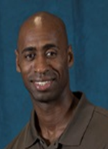 | 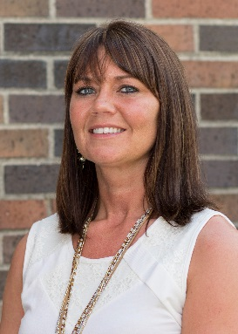  STACEY TOTTEN was a high school honor student who also earned a college degree. She started experimenting with drugs and alcohol and was later convicted on charges for dealing methamphetamine. Now she has earned a Master’s Degree, is a Certified Recovery Specialist, served as an HCI residential program supervisor and now works as Manager of Recovery Services for Hamilton Center, Inc. in the greater Indianapolis area.
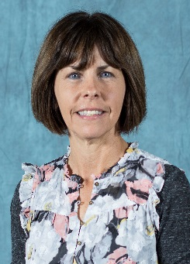  MELISSA HUTCHENS was introduced to illegal drugs at an early age. She dropped out of high school and started selling drugs to support her addiction. She was arrested on Federal charges and sentenced to 120 months in federal prison. Her crime was conspiracy to distribute methamphetamine. Now she is an Access Specialist and a Certified Recovery Specialist. | 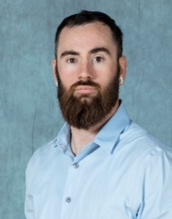  Joe Diehl was raised by a single mother in poverty and was given no guidance in his early life. He was charged with reckless homicide in 2014. Joe completed the New Citizen Program in 2018 and is now the Acting Facilities Manager.
“An individual has paid their debt to society after serving their sentence..”  ….Melvin L. Burks, CEO Hamilton Center  Contact Tatu Brown, Program Chairperson  620 Eighth Avenue, Terre Haute, IN 47804  tbrown@hamiltoncenter.org 812-231-8107 | Are you interested in bringing the New Citizen Program to your organization?

